**Day 6 Lab Assignments**

1. Create backup from your database (using three types) and try to restore it after drop.
   1. Explain when to use each type.
2. Create one database user and allow it to see some parts of DB and test it.
3. Create a clustered index on Employee table (EmpNo column).
   1. can it be created yes or no and why?
   2. If not, create new table, and try to create cluster index on the ID column of it.
   3. Can you create a clustered index on a column that isn’t a primary key?
   4. Does SQL server create a clustered index on the primary kery as default?
   5. Can you change it and make it as a non-clustered index and create a clustered index on other column?
4. Create non-clustered index on name column in employee table.
   1. What's an index? And what's its advantages and disadvantages? Why we use it?
   2. What's the difference between clustered and non-clustered index?

**Bonus:**

1. Return the result of this XML data as table (XML shredding):

<book genre="VB" publicationdate="2010">

<title>Writing VB Code</title>

<author>

<firstname>ITI</firstname>

<lastname>ITI</lastname>

</author>

<price>44.99</price>

</book>

* 1. Create a table according to the returned tabular data and insert the result on it (Search for: Create table as select statement).

1. Display all the data from the Employee table (HumanResources Schema) As an XML (Use: XML path).
2. Create an textQuestions table that contains: ID, QuesText, AnswerKeyWords (Untyped XML Column).
   1. Insert some records in the table.
   2. What’re the differences between Typed and untyped XML columns?
   3. Can you query from XML column based on a value of specific XML element or attribute? (Use XPath or XQuery) [**Bonus**].
3. Use JSON path, JSON Auto to Display all Product categories along with products of theses categories As a JSON.
4. Use JSON functions in SQL server to do the following on the given JSON data:

{“Persons”: [

{"PersonID":285,"FirstName":"Syed","MiddleName":"E","LastName":"Abbas", “Skills”: [“SQL server”, “BI”], “Education”:{“Degree”: “BSc”, “Faculty”: “FCI”}},

{"PersonID":293,"FirstName":"Catherine","MiddleName":"R.","LastName":"Abel"},

{"PersonID":295,"FirstName":"Kim","LastName":"Abercrombie}}

]}

* 1. Use JSONValue(), to display first name and last name.
  2. Use JSONQuery() to display the eduction info
  3. What’re the differences?

1. Giving the following query:

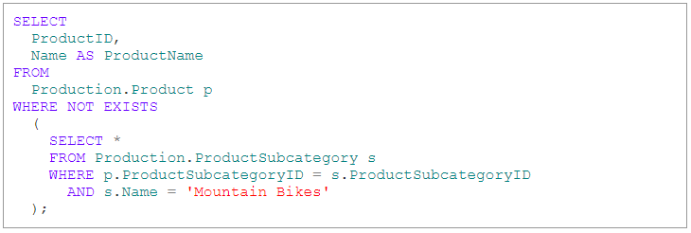

* 1. The previous query uses correlated sub-query, what’s it?
  2. “A correlated subquery, also known as a repeating subquery, is one that depends on the outer query for specific values.”, Explain the previous statement.
  3. What is the difference between correlated sub query and normal sub query?
  4. Explain the output of the previous query.
  5. Can sub-queries used in Insert, update and delete statements?
     1. You can refer to the following documentation: <https://docs.microsoft.com/en-us/sql/relational-databases/performance/subqueries?view=sql-server-ver15#upsert>
  6. What are the comparson operators: (*Any, Some, All*) that can be used with sub queries?
     1. You can refer to the following documentation: <https://docs.microsoft.com/en-us/sql/relational-databases/performance/subqueries?view=sql-server-ver15#comparison_modified>

1. Use correlated sub-query to display Prodcut categories that has products with ListPrice more than 1000.
2. Giving the following query:

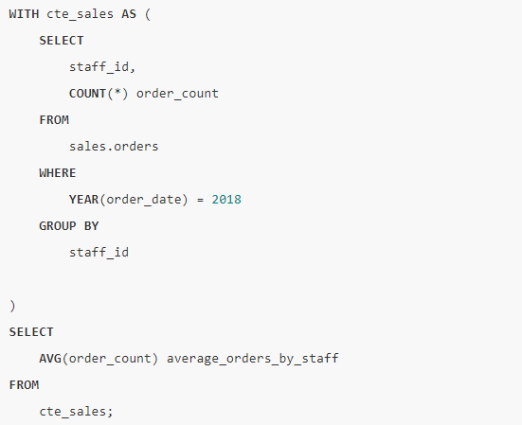

* 1. The previous query uses CTE, what’s CTE in SQL Server?
  2. Explain the output of the previous query?
  3. What are temp tables in SQL server? And What’re the differences between global and local temp tables?
  4. Implement the same query using temo table.
  5. Compare CTE to temp tables?

1. Use CTE to display number of products with ListPrice greater than 0 in each Category in Adventureworks.
2. Use JSON functions in SQL server to do the following on the given JSON data:

{“Persons”: [

{"Person":{"PersonID":285,"FirstName":"Syed","MiddleName":"E","LastName":"Abbas"}},

{"Person":{"PersonID":293,"FirstName":"Catherine","MiddleName":"R.","LastName":"Abel"}},

{"Person":{"PersonID":295,"FirstName":"Kim","LastName":"Abercrombie"}}

]}

* 1. Use JSONValue(), JSONQuery() functions to display the data in Tabular format.
  2. Use OpenJSON() function, to display the data in tabular format with specific columns names (different than names in the JSON object).
  3. Create a table according to the returned tabular data and insert the result on it (Create table as select statement).
  4. Make a function that take the previos JSON object, and index as a parameters and return table with keys, values for the given index (keys and values for person with the given index).

1. Create this table, and insert these data on it:

CREATE TABLE docs

(

ID int PRIMARY KEY,

BOOK XML

)

INSERT INTO docs

VALUES

(1,'<book genre="CPP" publicationdate="1985">

<title>Writing CPP Code</title>

<author>

<firstname>Michael</firstname>

<lastname>Howard</lastname>

</author>

<price>39.99</price>

</book>')

INSERT INTO docs

VALUES

(2,'<book genre="VB" publicationdate="2010">

<title>Writing VB Code</title>

<author>

<firstname>ITI</firstname>

<lastname>ITI</lastname>

</author>

<price>44.99</price>

</book>')

Then select the value of firstname for the first book using Xquery.

**Enrich your SQL server development skills (Self-study) [Big Bonus]:**

* What's bulk insert? Explain using and example.
* What’re the uses of Pivot and Unpivot in SQL Server?
  + You can refer to: <https://docs.microsoft.com/en-us/sql/t-sql/queries/from-using-pivot-and-unpivot?view=sql-server-ver15>
* What’s SQL server Ranking functions?
  + You can refer to: <https://docs.microsoft.com/en-us/sql/t-sql/functions/ranking-functions-transact-sql?view=sql-server-ver15>
* What’re sql server wide table and sparse column?
  + <https://docs.microsoft.com/en-us/sql/relational-databases/tables/use-sparse-columns?view=sql-server-ver15>
  + <https://docs.microsoft.com/en-us/sql/relational-databases/tables/tables?view=sql-server-ver15#wide-tables>
* What’s SQL server Full-text search?
  + <https://docs.microsoft.com/en-us/sql/relational-databases/search/full-text-search?view=sql-server-ver15>
* What’s partitioned tables?
  + <https://docs.microsoft.com/en-us/sql/relational-databases/partitions/partitioned-tables-and-indexes?view=sql-server-ver15>
* What’re the database recovery models?
  + <https://docs.microsoft.com/en-us/sql/relational-databases/backup-restore/recovery-models-sql-server?view=sql-server-ver15>
* What are SQLSCLR? Make a demo on SQLCLR functions, triggers.
* SQL server administration basics:
  + SQL server administration videos:
    - <https://drive.google.com/drive/u/0/folders/1uoi7VNHh1-oxcpIYsufB6bWlGeiwquQl>
  + Databases backup and restore
    - <https://docs.microsoft.com/en-us/sql/relational-databases/backup-restore/back-up-and-restore-of-sql-server-databases?view=sql-server-ver15>
  + What’s a database snapshot?
    - <https://docs.microsoft.com/en-us/sql/relational-databases/databases/database-snapshots-sql-server?view=sql-server-ver15>
  + Automating SQL server (Jobs and schedules)
    - <https://docs.microsoft.com/en-us/sql/ssms/agent/sql-server-agent?view=sql-server-ver15>
  + SQL server security model (Logins, users, permissions)
    - <https://docs.microsoft.com/en-us/sql/relational-databases/security/authentication-access/determining-effective-database-engine-permissions?view=sql-server-ver15>